Name: Muhammad Talha
Reg: UW-24-CS-BS-101

Program 2
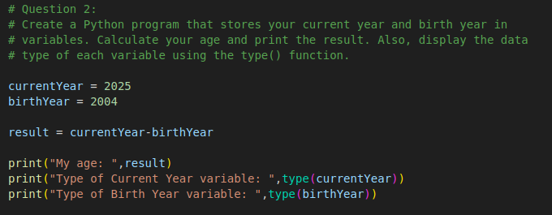
Program 3

